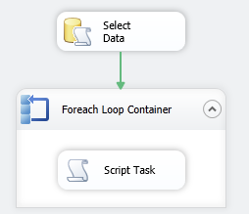

Create 3 variables

* Variable type Object
* EmpId type String (or Object)
* PersonID type String (or Object)

SSIS -> Variables

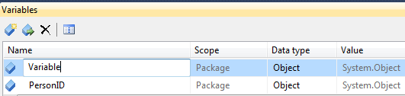

Execute SQL Task

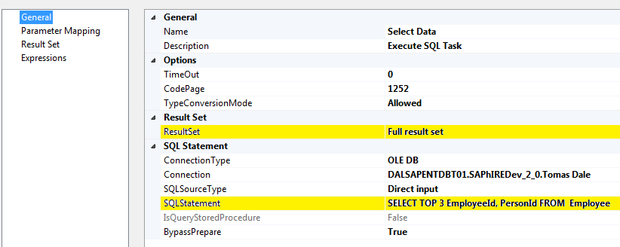

Set the output to a variable type Object (Variable)

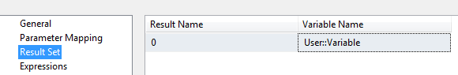

You can use a For Each loop to shred the retrieved result set by selecting the For Each ADO enumerator, and mapping the columns in the result set to variables. The For Each will run once per row in the result set, setting the variable values to match the current row.

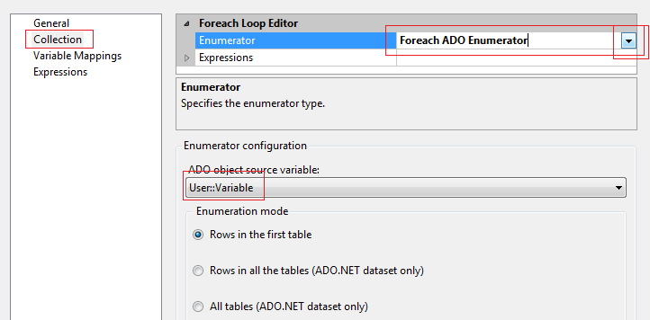

Set Variable Mapping

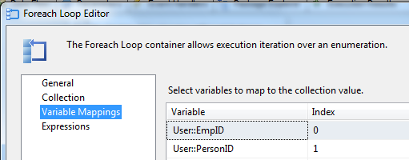

**SCRIPT**

Set the entry variables EmpID and PersonID

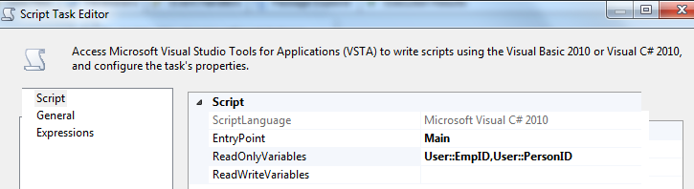

VB

**MsgBox(Dts.Variables("EmpID").Value)**

C#

MessageBox.Show(Dts.Variables["EmpID"].Value.ToString());

http://www.youtube.com/watch?v=a0-u1mw_kMI

The next Execute SQL task is a little more interesting. It inserts the header row and uses the T-SQL OUTPUT clause to return the identity value for that row.

INSERT INTO dbo.ImportData (EndDate) VALUES ( ? );

SELECT ? = SCOPE_IDENTITY()

You can also execute a second SQL statement in the same task to get the identity value using [@@IDENTITY](http://msdn.microsoft.com/en-us/library/ms187342.aspx) (be aware that there are some constraints when using this) or [SCOPE_IDENTITY()](http://msdn.microsoft.com/en-us/library/ms190315.aspx).

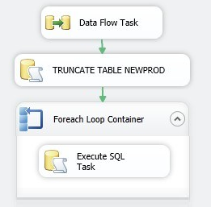

**Data Flow Task**

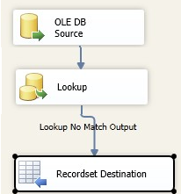

Source

Lookup

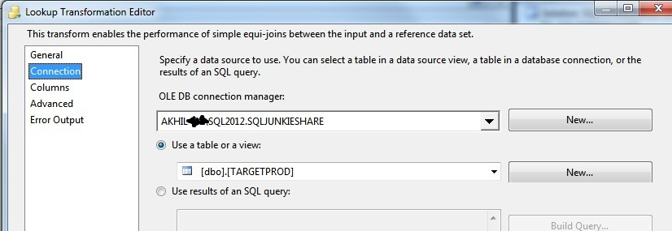

Recordset

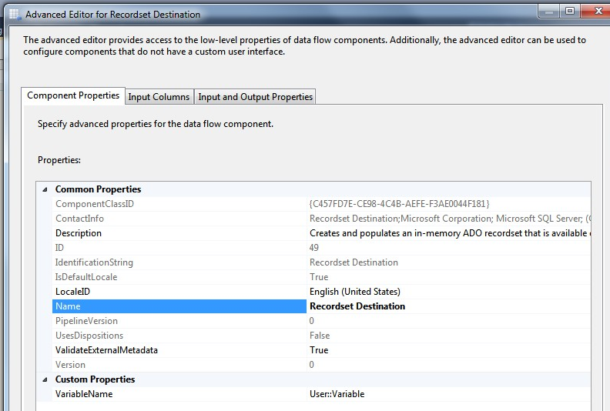

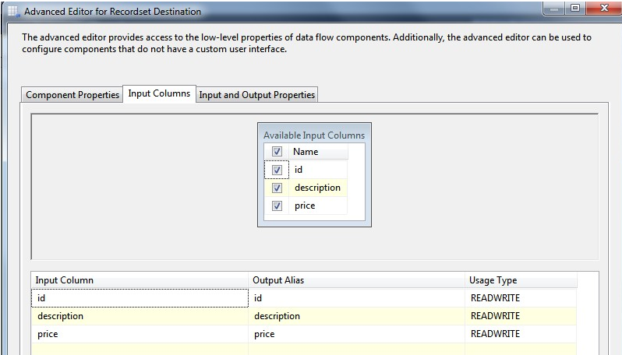

FOREACH

